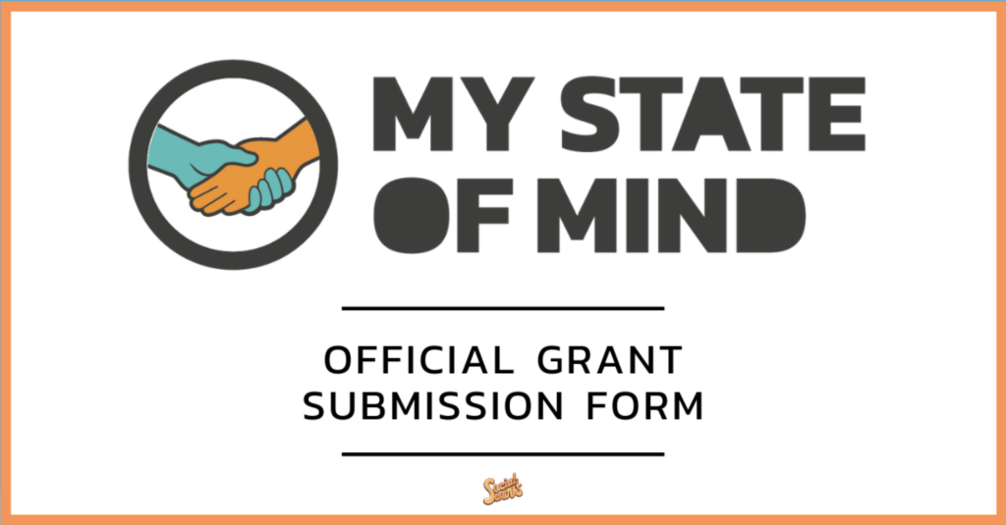

Please complete the following application to be considered for the My State of Mind grant. Feel free to provide as much information as possible so the My State of Mind team may have the best possible consideration for determining our grantees. This form, in its completion, is due May 29, 2019 at 11:59pm. Please submit the completed form to the SocialWorks Dropbox here. We look forward to reviewing your submission!

Fiscal Sponsor Name:

Legal Name:

Mailing Address:

City:

State:

Zip Code:

Contact Name:
Contact Position:
Contact Telephone #:
Contact Email:

Website URL:
Social Media Handles:

Year Organization was Founded:

Organization Mission & Values:

Does your organization have written policies that discriminate against individuals based on race, color, sex, sexual orientation, gender identity, religious creed, national origin, physical or mental disability, or protected veteran status or any other characteristic protected by law (Yes/No):

What is the program title?:

What will the proposed grant be used to support?:

Please describe how the program will be staffed and each staff member’s role?:

Will the program require volunteer work or help?:

Are you aware of other organizations, churches, agencies, or individuals in your community offering the same programs?:

If so, what makes your program unique and necessary?:

Does your proposal connect to existing resources in the community? If so, how?:

What is your target population for your program?:

What is the age range to be served?:

What is the organization’s prior experience working with the target population(s) identified above?:

What are the mental health related challenges in the community you serve?

How would your program/service address those challenges?:

What are the proposed measurable outcomes and evaluation plan? For each outcome, identify the indicator and its projected success rate, the data source(s), and data collection method? For example: Outcome: Participants will be cared for holistically, receiving all necessary physical and mental health services. Indicator and projection: At least 75% of participants will be enrolled in mental and physical health services. Data source: Client healthy history

Explain how activities, and outcomes identified above align with showing progress in one or more of the following goals: Improving access to care for vulnerable populations? Reducing health disparities? Increasing quality and affordability of health care? Promoting health and wellness?

What organizational structure do you have in place to manage the requested funds?:

Have you received funding in the past?:

MSOM aims to unify the broader mental health community, increase the access and visibility of services, and make it admirable to be honest with yourself. How does your program accomplish this?:

What are your projected budgeted expenses?:

Do you have other funding sources?:

How will this program be sustained once the grant funds have been spent (i.e. continuance of care plan)?:

Want an ACH? (Yes/ No):
If yes, please complete the following:
Bank Name:
Bank Address:
Name of Account:
Account Type:
Routing #
Account #

Do you have any concerns if you were to be awarded this grant?:

Describe your current staffing:

Discuss your organization’s current programming?:

If awarded, who will be your project liaison for the grant?:

How would you accomplish your goals if you did not receive this grant?:

*ATTACHMENTS - 1) Proposed budget for the grant program, 2) your organization’s W9, and 3) current examples of programming using photo/video(s)/flyers.

